**COEN 281**

**Assignment 1**

1. Boxplot representing number of outstate students going to private school

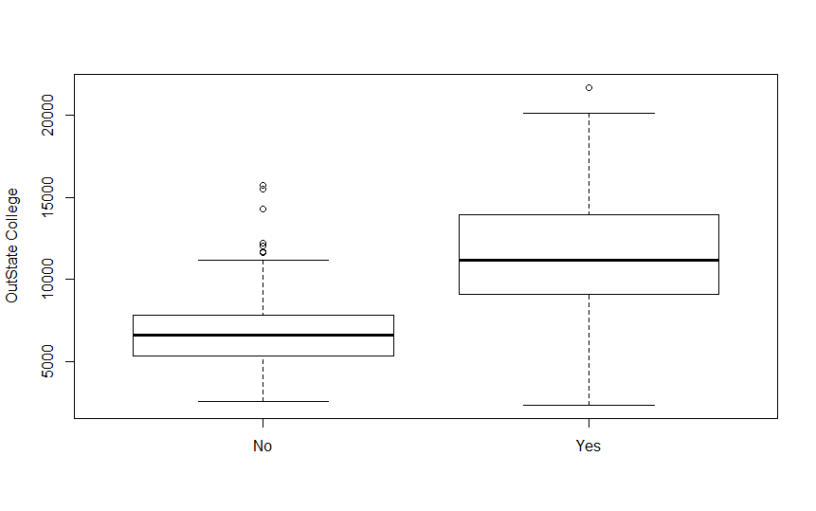

Boxplot dividing universities into two groups based on whether or not the proportion of students coming from the top 10% of their high school classes exceeds 50%.

x<-College$Private

y<-College$Outstate

plot(x,y)

Elite=rep("No",nrow(College))

Elite[College$Top10perc > 50]="Yes"

Elite=as.factor(Elite)

College=data.frame(College,Elite)

plot(College$Elite,College$Outstate, ylab="Colleges")

